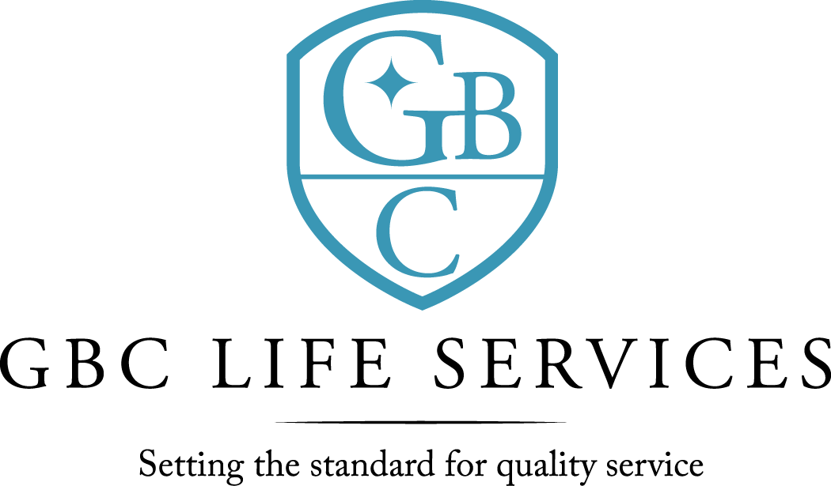
211 North 3rd St. ~ Monroe, LA 71201

There was a regular meeting of the Board of Commissioners of G. B. Cooley Hospital Service District held on Thursday, January 13, 2022 at 4:30PM in the Training Room of the G. B. Cooley Administration Building located at 211 N. 3rd Street, Monroe, LA.

Call to Order: Cindy Johns, Co-Chairperson, called the meeting to order, there being a quorum present.

Board Members Present:
Cindy Johns, TaRonda Goodin, Jackie S. Slack, Kenneth Wilson, Lynn Wilson, and Dawn Stanfield

Board Members Absent: Dan Sartor

Others Present: Ben Pitts, Jimmy Sanderlin, Connie Page, Christian Creed and Angelique Andrews.

Prayer: The invocation was offered by Ben Pitts
Public Comments: There were none.

Minutes: The minutes for December 9, 2021, Board meeting were presented. The minutes were previously forwarded to Commissioners. A motion was offered by Kenneth Wilson, seconded by Lynn Wilson, and unanimously carried by the Commissioners present to waive the reading of the 12-9-2021 minutes.

New Business: A motion was offered by Jackie S. Slack, seconded by Dawn Stanfield and unanimously carried by the Commissioners move to amend December 9, 2021 minutes to include the Commissioners approval of the amended budget. There is a pending public hearing set for 01-17-2022.

1-13-22 Board Meeting page 2

Reports:
a) Financial Report was for the month of November and the five months ending
November 30, 2021. Operating revenues was under budget for the month by $ 61,898 and under budget for five months by $ 89,812. Operating expenses for the month was under budget by $44,777. Year to date was under budget by $101,929. For the month the expenses exceeded Revenue by $ 12,281 and year to date revenue exceeded expenses by $36,362. For expense comparison variances of 5% and $5,000 was used as the model. Maintenance – Building and Maintenance – Furniture are the two major expenses over variance. Questions and comments were addressed.

b) Ben Pitts, CEO, presented a monthly report. Facility census ending December was (119) in community homes; (26) in SIL; (2) in Therapeutic Group Home (TGH); and (19) in Employment Program. There were no admits and had (2) discharges during the month. The Abuse/Neglect Allegations Report showed (1) valid allegation. At the end of December 2021, there were (222) employees with a 1% turnover rate.
COVID 19 update: During the month of December, there were the following reports of positive cases of COVID-19: (5) were staff members and (1) consumer, with (4) locations being quarantined. Federal Mandate- UPDATE – Supreme Court has upheld the CMS vaccination mandate for healthcare employees. Compliance will be completed by date required.

Public Comments: There were none.

Commissioners’ Statements/Discussion: There were none.

Adjournment: There being no further business, a motion was offered by Kenneth Wilson, seconded by TaRonda Goodin, and unanimously carried by the Commissioners present to adjourn the meeting. The meeting adjourned at 5:35 PM.
.

Cindy Johns, Co-Chairperson Ben Pitts, Hospital Director
G. B. Cooley Board of Commissioners G. B. Cooley Hospital Service District

