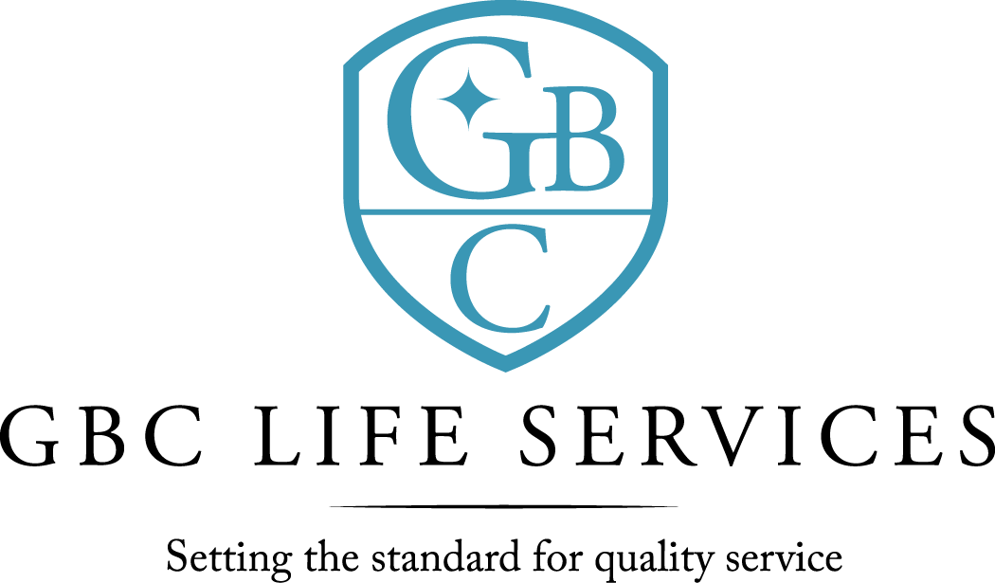
211 North 3rd St. ~ Monroe, LA 71201

There was a regular meeting of the Board of Commissioners of G. B. Cooley Hospital Service District held on Thursday March 10, 2022 at 4:30PM in the Training Room of the G. B. Cooley Administration Building located at 211 N. 3rd Street, Monroe, LA.

Call to Order: Dan Sartor, Chairperson, called the meeting to order, there being a quorum present.

Board Members Present:
Dan Sartor, Cindy Johns, Jackie S. Slack, Kenneth Wilson, Dawn Stanfield, and TaRonda Goodin.

Board Members Absent: Lynn Wilson

Others Present: Ben Pitts, Jimmy Sanderlin, Connie Page, Angelique Andrews, and Christian Creed.

Prayer: The invocation was offered by Ben Pitts
Public Comments: There were none.

Minutes: The minutes for February 10, 2022 Board meeting were presented. The minutes were previously forwarded to Commissioners. A motion was offered by Kenneth Wilson, seconded by Dawn Stanfield, and unanimously carried by the Commissioners present to waive the reading of the 2-10-22 minutes. A motion was offered by Jackie S. Slack, seconded by Kenneth Wilson, and unanimously carried by the Commissioners present to approve the 2-10-22 minutes as presented.

New Business: 2020-2021 Financial Audit Report (Woodard & Associates)
“Lori Woodard, CPA provided Financial Audit Report for fiscal year 2020-2021 and answered questions by commissioners.”

3-10-22 Board Meeting page 2

Reports:
- The Financial Report for month of November and the seven months ending January 31,2022 was presented by Jimmy Sanderlin, CFO. Operating Revenues was under budget for the month by $ 25,767 and under budget for the seven months by $ 148,932. Operating expenses for the month was over budget by $15,383. Year to date was under budget by $15,964. For the month the expenses exceeded Revenue by $ 36,311 and year to date expenses exceeded revenue by $99,091 For expense comparison variances of 5% and $5,000 was used as the model. Salaries were over budget Questions and comments were addressed.

- Monthly Report was given by Ben Pitts, CEO. Facility total census is (177) with (118) in community homes; (26) in SIL; (1) in TGH; and (19) in Employment Program. There was (0) discharge in community homes and (1) TGH admit. There were no allegations of abuse/neglect during the month of January. Total employees on payroll at the end of Feb was (231), with a turnover rate of .07%. February 2022 COVID 19 update: All staff are either fully vaccinated or have an approved exemption (90 % fully vaccinated).

Public Comments: There were none.

Commissioners’ Statements/Discussion: There were none.

Adjournment: There being no further business, a motion was offered by Kenneth Wilson, seconded by Cindy Johns, and unanimously carried by the Commissioners present to adjourn the meeting. The meeting adjourned at 5:38 PM.

Dan Sartor, Chairperson Ben Pitts, Hospital Director
G. B. Cooley Board of Commissioners G. B. Cooley Hospital Service District

