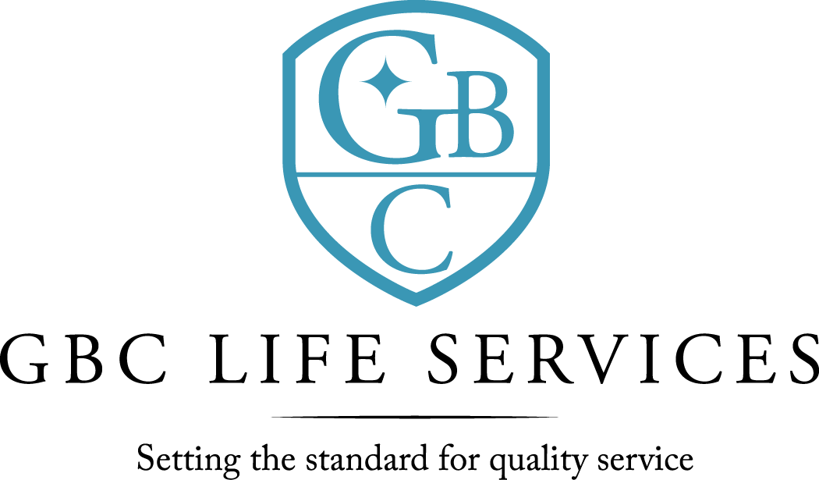
211 North 3rd St. ~ Monroe, LA 71201

There was a regular meeting of the Board of Commissioners of G. B. Cooley Hospital Service District held on Thursday April 14, 2022, at 4:30PM in the Training Room of the G. B. Cooley Administration Building located at 211 N. 3rd Street, Monroe, LA.

Call to Order: Dan Sartor, Chairperson, called the meeting to order, there being a quorum present.

Board Members Present: Dan Sartor, Cindy Johns, TaRonda Goodin, Lynn Wilson, and Dawn Stanfield (by phone).

Board Members Absent: Jackie S. Slack and Kenneth Wilson

Others Present: Ben Pitts, Jimmy Sanderlin, Connie Page, and Angelique Andrews.

Prayer: The invocation was offered by Lynn Wilson
Public Comments: There were none.

Minutes: The minutes for March 10, 2022, Board meeting were presented. The minutes were previously forwarded to Commissioners. A motion was offered by TaRonda Gooding, seconded by Dawn Stanfield, and unanimously carried by the Commissioners present to waive the reading of the 3-10-2022 minutes. A motion was offered by Cindy Johns, seconded by Lynn Wilson, and unanimously carried by the Commissioners present to approve the 3-10-2022 minutes as presented.

Unfinished Business: A motion was offered by Cindy Johns, seconded by Dawn Stanfield, and unanimously carried by the Commissioners present to accept the Personnel Policies changes.

4-14-2022 Board Meeting page 2

Reports:
- The Financial Report for month ended month of November and the seven months ending February 28, 2022 was presented by Jimmy Sanderlin, CFO. Operating Revenues was under budget for the month by $ 98,535 and under budget for the seven months by $ 247,467. Operating expenses for the month was under budget by $120,506. Year to date was under budget by $128,176. For the month the Revenue exceeded expenses by $ 26,810 and year to date expenses exceeded revenue by $119,291. For expense comparison variances of 5% and $5,000 was used as the model. Office Equipment and Building Maintenance was over budget. Questions and comments were addressed.
- Monthly Report was given by Ben Pitts, Director. Facility total census is (177) with (120) in community homes; (26) in SIL; (2) in TGH; and (19) in Employment Program. There was (0) discharge in community homes and (3) admits. There were no allegations of abuse/neglect during the month of March. Total employees on payroll at the end of March were (224), with a turnover rate of .04%.

Public Comments: There were none.

Commissioners’ Statements/Discussion: There were none.

Executive Session: Upon motion duly made and seconded, it was moved that the Board of Selectmen go into EXECUTIVE SESSION in accordance with M.G.L. Ch 39, Sec. 23B.

The Board / Committee WILL NOT RECONVENE in Open Meeting after the Executive Session

Adjournment: There being no further business, a motion was offered by Dawn Stanfield, seconded by Cindy Johns, and unanimously carried by the Commissioners present to adjourn the meeting. The meeting adjourned at 5:35 PM.

Dan Sartor, Chairperson Ben Pitts, Hospital Director
G. B. Cooley Board of Commissioners G. B. Cooley Hospital Service District

