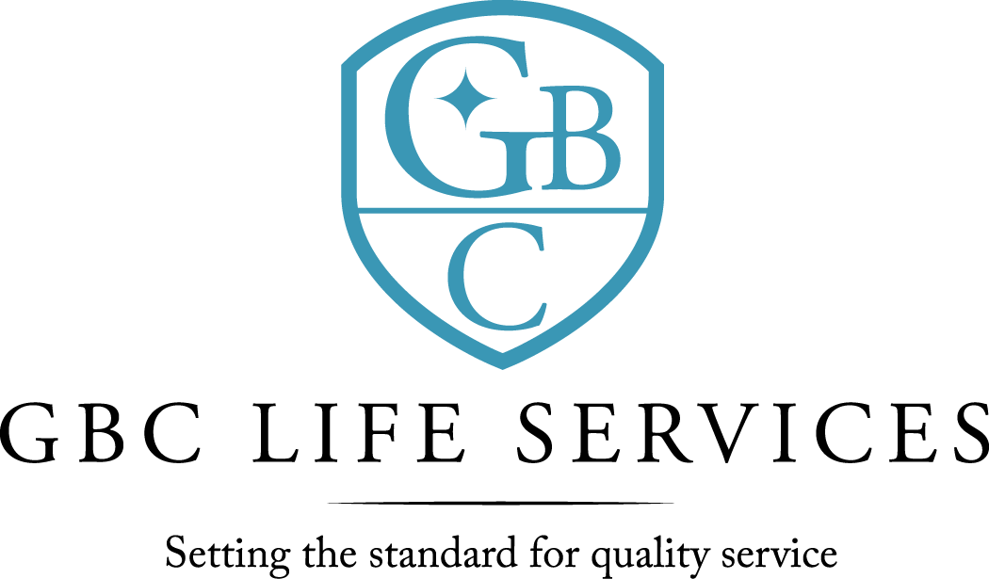
211 North 3rd St. ~ Monroe, LA 71201

There was a regular meeting of the Board of Commissioners of G. B. Cooley Hospital Service District held on Thursday, May 12, 2022 at 4:30PM in the Training Room of the G. B. Cooley Administration Building located at 211 N. 3rd Street, Monroe, LA.

Call to Order: Dan Sartor, Chairperson, called the meeting to order, there being a quorum present.

Board Members Present: Dan Sartor, Cindy Johns, TaRonda Goodin, Lynn Wilson, Dawn Stanfield, and Kenneth Wilson (by phone)

Board Members Absent: Jackie S. Slack

Others Present: Ben Pitts, Jimmy Sanderlin, Connie Page, Angelique Andrews, and Christian Creed (by phone)

Prayer: The invocation was offered by Ben Pitts
Public Comments: There were none.

Minutes: The minutes for April 14, 2022, Board meeting were presented. The minutes were previously forwarded to Commissioners. A motion was offered by Lynn Wilson, seconded by Dawn Stanfield, and unanimously carried by the Commissioners present to waive the reading of the 4-14-2022 minutes. A motion was offered by Dawn Stanfield, seconded by Dan Sartor, and unanimously carried by the Commissioners present to approve the 4-14-2022 minutes as presented.

New Business: Jimmy Sanderlin, CFO, presented the Proposed Operating Budget and Proposed Capital Outlay Budget for the 2022-2023 fiscal year. After questions were addressed, Cindy Johns made a motion to approve the proposed Operating Budget and Proposed Capital Outlay Budget for the 2022-2023 fiscal year pending the public hearing. Lynn Wilson seconded the motion and the motion carried. Dan Sartor- Yes; Cindy Johns- Yes; Lynn Wilson- Yes; TaRonda Goodin- Yes; Dawn Stanfield- Yes; Kenneth Wilson- Yes by phone; Nays: - Jackie S. Slack.

5-12-2022 Board Meeting page 2

New Business: A motion was offered by Dan Sartor, seconded by Lynn Wilson, and unanimously carried by the Commissioners present to approve advertisement of surplus vans in News Star World and Monroe Dispatch for a surplus sale.

Reports:
- The Financial Report for month ended month of March and the nine months ending March 31, 2022 was presented by Jimmy Sanderlin, CFO. Operating Revenues was under budget for the month by $ 9,861 and under budget for the seven months by $ 257,329. Operating expenses for the month was under budget by $33,176. Year to date was under budget by $124,542. For the month the Revenue exceeded expenses by $ 28,154 and year to date expenses exceeded revenue by $89,230. For expense comparison variances of 5% and $5,000 was used as the model. Building Maintenance was over budget. Questions and comments were addressed.
- Monthly Report was given by Ben Pitts, Director. Facility total census is (178) with (121) in community homes; (26) in SIL; (1) in TGH; and (19) in Employment Program. There was (0) discharge in community homes and (1) admit. There were no allegations of abuse/neglect during the month of April. Total employees on payroll at the end of April were (226), with a turnover rate of .03%. Ben Pitts, Director, updated the board on the need for possible expansion of behavioral health services. A more detailed plan for the board to considered will be offered at a future meeting.

Public Comments: There were none.

Commissioners’ Statements/Discussion: There were none.

Executive Session: Upon motion duly made and seconded, it was moved that the Board of Selectmen go into EXECUTIVE SESSION in accordance with M.G.L. Ch 39, Sec. 23B.

The Board / Committee WILL NOT RECONVENE in Open Meeting after the Executive Session

Adjournment: There being no further business, a motion was offered by Dawn Stanfield, seconded by Cindy Johns, and unanimously carried by the Commissioners present to adjourn the meeting. The meeting adjourned at 5:35 PM.

Dan Sartor, Chairperson Ben Pitts, Hospital Director
G. B. Cooley Board of Commissioners G. B. Cooley Hospital Service District

