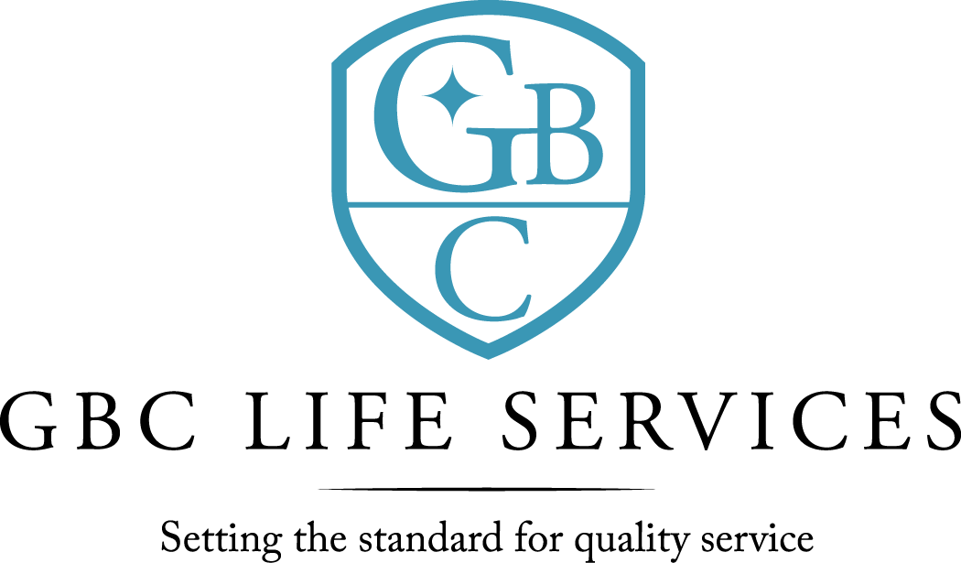
211 North 3rd St. ~ Monroe, LA 71201

There was a regular meeting of the Board of Commissioners of G. B. Cooley Hospital Service District held on Thursday, June 9, 2022 at 4:30PM in the Training Room of the G. B. Cooley Administration Building located at 211 N. 3rd Street, Monroe, LA.

Call to Order: Dan Sartor, Chairperson, called the meeting to order, there being a quorum present.

Board Members Present: Dan Sartor, Jackie S. Slack, Kenneth Wilson, Lynn Wilson, and Dawn Stanfield.

Board Members Absent: Cindy Johns and TaRonda Goodin

Others Present: Ben Pitts, Jimmy Sanderlin, Angelique Andrews, and Christian Creed

Prayer: The invocation was offered by Kenneth Wilson.
Public Comments: There were none.

Minutes: The minutes for May 12, 2022, Board meeting were presented. The minutes were previously forwarded to Commissioners. A motion was offered by Lynn Wilson, seconded by Dawn Stanfield, and unanimously carried by the Commissioners present to waive the reading of the 5-12-22 minutes. A motion was offered by Dan Sartor, seconded by Kenneth Wilson, and unanimously carried by the Commissioners present to approve the 5-12-22 minutes as presented.

06-09-2022 Board Meeting page 2

Reports:
- The Financial Report for month ended month of April and the ten months ending April 30, 2022 was presented by Jimmy Sanderlin, CFO. Operating Revenues was under budget for the month by $ 47,755 and under budget for the seven months by $ 305,083. Operating expenses for the month was under budget by $57,9355 Year to date was under budget by $178,240. For the month the Revenue exceeded expenses by $ 15,020 and year to date expenses exceeded revenue by $77,447. For expense comparison variances of 5% and $5,000 was used as the model. Questions and comments were addressed.
- Monthly Report was given by Ben Pitts, Director. Facility total census is (176) with (119) in community homes; (26) in SIL; (1) in TGH; and (19) in Employment Program. There were (2) discharges in community homes and (1) admit. There were no allegations of abuse/neglect during the month of May. Total employees on payroll at the end of May were (226) with the following breakdown,
(20 applications; 6 hired: 5 separations - +1) with a turnover rate of .03%. Ben Pitts, Director, updated the board with more information on the need for possible expansion of behavioral health services. A more detailed plan for the board to considered will be offered at a future meeting.

New Business: Election of Board Officers for 2022-2023 year. A motion was offered by Kenneth Wilson, seconded by Jackie S. Slack, and was carried by the Commissioners with the continuation of Dan Sartor as Chairperson of GBC’s Board of Commissioners and Cindy Johns as Co-Chairperson for the 2022-2023 year. Dan Sartor- Yes; Lynn Wilson- Yes; Kenneth Wilson – Yes; Dawn Stanfield-Yes.

Public Comments: There were none.

Commissioners’ Statements/Discussion: There were none.

Adjournment: There being no further business, a motion was offered by Kenneth Wilson, seconded by Jackie S. Slack, and unanimously carried by the Commissioners present to adjourn the meeting. The meeting adjourned at 5:37 PM.

Dan Sartor, Chairperson Ben Pitts, Hospital Director
G. B. Cooley Board of Commissioners G. B. Cooley Hospital Service District

