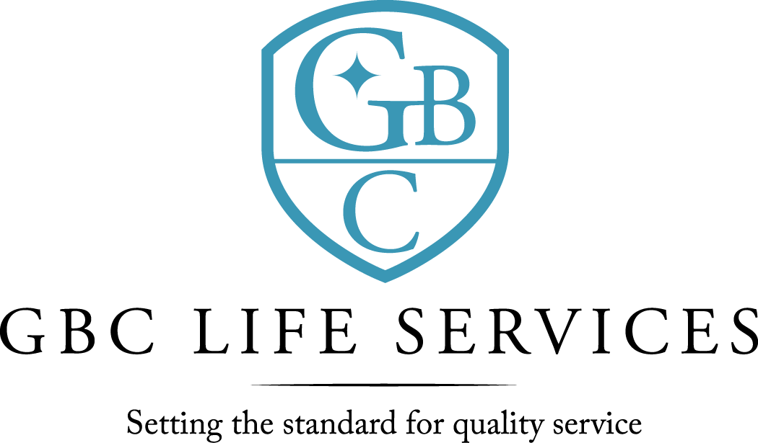
211 North 3rd St. ~ Monroe, LA 71201

There was a regular meeting of the Board of Commissioners of G. B. Cooley Hospital Service District held on Thursday, July 14, 2022 at 4:30PM in the Training Room of the G. B. Cooley Administration Building located at 211 N. 3rd Street, Monroe, LA.

Call to Order: Dan Sartor, Chairperson, called the meeting to order, there being a quorum present.

Board Members Present: Dan Sartor, Cindy Johns, TaRonda Goodin, Jackie S. Slack, Kenneth Wilson, Lynn Wilson, and Dawn Stanfield.

Board Members Absent: None

Others Present: Ben Pitts, Jimmy Sanderlin, Connie Page, Angelique Andrews, and Christian Creed.

Prayer: The invocation was offered by Lynn Wilson
Public Comments: There were none.

Minutes: The minutes for June 9, 2022, Board meeting were presented. The minutes were previously forwarded to Commissioners. A motion was offered by TaRonda Goodin, seconded by Jackie S. Slack, and unanimously carried by the Commissioners present to waive the reading of the 6-9-2022 minutes. A motion was offered by Dan Sartor, seconded by TaRonda Goodin, and unanimously carried by the Commissioners present to approve the 6-9-2022 minutes as presented.

7-14-2022 Board Meeting page 2

Reports:
  - The Financial Report was for the month of May and the eleven months ending May 2022 was presented by Jimmy Sanderlin, CFO. Operating Revenues was under budget for the month by $10,022 and under budget for the eleven months by $ 315,247. Operating expenses for the month was over budget by $36,942. Year to date was under budget by $120,995. For the month the Expenses exceeded Revenue by $46,964 and year to date expenses exceeded revenue by $ 194,252. For expense comparison variances of 5% and $5,000 was used as the model. Questions and comments were addressed.

- Monthly Report was given by Ben Pitts, Director. Facility total census is (175) with (118) in community homes; (26) in SIL; (1) in TGH; and (19) in Employment Program. There were (1) discharges in community homes. There was (1) allegation of abuse/neglect during the month of June. Staff employment terminated. Total employees on payroll at the end of June were (238): up from 226 last month) with a turnover rate of .03%. Ben Pitts, Director, updated the board with more information on the need for possible expansion of behavioral health services. A more detailed plan for the board to considered will be offered at a future meeting. Surplus sale was completed with all bids submitted. All van sales have been completed and paid for.

Public Comments: There were none.

Commissioners’ Statements/Discussion: There were none.

Adjournment: There being no further business, a motion was offered by Cindy Johns, seconded by Dawn Stanfield, and unanimously carried by the Commissioners present to adjourn the meeting. The meeting adjourned at 5:39 PM.

Dan Sartor, Chairperson Ben Pitts, Hospital Director
G. B. Cooley Board of Commissioners G. B. Cooley Hospital Service District

